SUBJECT: OBJECT ORIENTED PROGRAMMING

Submitted To: Engr. Asmatullah

Submitted By: Asadullah Samo (21SW036)

Dated: 30-09-2022

Lab: Lab-11 & 12 Task

**Question:**

01. Write an GUI Application that capture following information of a Student :

1. Reg. No. 2. Name 3. Batch 4. Section

5. Gender (must be a choice object) e.g. Radio Button

6. Qualification (must be a choice object) e.g. Check Box

7. Address (must have multiple lines) e.g. TextArea

8. Country (must be list item) e.g. ComboBox

This application must have 2 buttons on the screen one is for Save and one for Display, when user selects Save then all fields will be initialized, and data will be stored in JSON file. On pressing display button all the data will be shown on new frame.

Create a colorful GUI by adding background color or image to buttons and frame.

Source Code:

**package** Lab_11_12_Task;

**import** org.json.simple.JSONObject;

**import** javax.swing.*;

**import** java.awt.*;

**import** java.awt.event.ActionEvent;

**import** java.awt.event.ActionListener;

**import** java.io.FileWriter;

**import** java.io.Writer;

**class** Form **extends** JFrame **implements** ActionListener {

JLabel jl1, jl2, jl3, jl4, jl5, jl6, jl7, jl8;

JTextField roll_no, name, batch, section;

JRadioButton jb1, jb2;

JButton b1, b2;

JCheckBox checkBox1, checkBox2, checkBox3, checkBox4;

JTextArea address;

JComboBox country;

**public** Form() {

setSize(620, 620);

setDefaultCloseOperation(JFrame.EXIT_ON_CLOSE);

setLayout(**null**);

getContentPane().setBackground(Color.YELLOW);

jl1 = **new** JLabel("Name ");

jl2 = **new** JLabel("Roll No ");

jl3 = **new** JLabel("Batch ");

jl4 = **new** JLabel("Section ");

jl5 = **new** JLabel("Gender ");

jl6 = **new** JLabel("Qualification ");

jl7 = **new** JLabel("Address ");

jl8 = **new** JLabel("Country");

jl1.setBounds(50, 50, 75, 25);

jl2.setBounds(50, 100, 75, 25);

jl3.setBounds(50, 150, 75, 25);

jl4.setBounds(50, 200, 75, 25);

jl5.setBounds(50, 250, 75, 25);

jl6.setBounds(50, 300, 75, 25);

jl7.setBounds(50, 400, 75, 25);

jl8.setBounds(50, 450, 75, 25);

roll_no = **new** JTextField(20);

name = **new** JTextField(20);

batch = **new** JTextField(20);

section = **new** JTextField(20);

name.setBounds(125, 50, 200, 25);

roll_no.setBounds(125, 100, 200, 25);

batch.setBounds(125, 150, 200, 25);

section.setBounds(125, 200, 200, 25);

jb1 = **new** JRadioButton("Male");

jb2 = **new** JRadioButton("Female");

jb1.setBackground(Color.yellow);

jb2.setBackground(Color.yellow);

ButtonGroup bg = **new** ButtonGroup();

bg.add(jb1);

bg.add(jb2);

jb1.setBounds(150, 250, 80, 25);

jb2.setBounds(250, 250, 80, 25);

checkBox1 = **new** JCheckBox("Matric");

checkBox2 = **new** JCheckBox("Intermediate");

checkBox3 = **new** JCheckBox("Graduate");

checkBox4 = **new** JCheckBox("Post Graduate");

checkBox1.setBackground(Color.yellow);

checkBox2.setBackground(Color.yellow);

checkBox3.setBackground(Color.yellow);

checkBox4.setBackground(Color.yellow);

checkBox1.setBounds(150, 300, 80, 25);

checkBox2.setBounds(250, 300, 120, 25);

checkBox3.setBounds(150, 350, 100, 25);

checkBox4.setBounds(250, 350, 130, 25);

address = **new** JTextArea();

address.setLineWrap(**true**);

address.setWrapStyleWord(**true**);

address.setBounds(150, 400, 220, 40);

String[] countries = {"Pakistan", "India", "China"};

country = **new** JComboBox(countries);

country.setBounds(150, 450, 160, 25);

b1 = **new** JButton("Save");

b2 = **new** JButton("Print");

b1.setFocusable(**false**);

b2.setFocusable(**false**);

b1.setBounds(50, 500, 75, 25);

b2.setBounds(150, 500, 75, 25);

add(jl1);

add(name);

add(jl2);

add(roll_no);

add(jl3);

add(batch);

add(jl4);

add(section);

add(jl5);

add(jb1);

add(jb2);

add(jl6);

add(checkBox1);

add(checkBox2);

add(checkBox3);

add(checkBox4);

add(jl7);

add(address);

add(jl8);

add(country);

add(b1);

add(b2);

b1.addActionListener(**this**);

b2.addActionListener(**this**);

setVisible(**true**);

}

@Override

**public** **void** actionPerformed(ActionEvent e) {

Writer writer;

JSONObject jsonObject = **new** JSONObject();

jsonObject.put("Name", name.getText());

jsonObject.put("Roll Number: ", roll_no.getText());

jsonObject.put("Batch: ", batch.getText());

jsonObject.put("Section: ", section.getText());

**if** (jb1.isSelected()) {

jsonObject.put("Gender: ", jb1.getText());

} **else** {

jsonObject.put("Gender: ", jb2.getText());

}

**if** (checkBox1.isSelected() && checkBox2.isSelected() && checkBox3.isSelected() && checkBox4.isSelected()) {

jsonObject.put("Qualification: ", checkBox1.getText() + ", " + checkBox2.getText() + ", " + checkBox3.getText() + " and " + checkBox4.getText());

} **else** **if** (checkBox1.isSelected() && checkBox2.isSelected() && checkBox3.isSelected()) {

jsonObject.put("Qualification: ", checkBox1.getText() + ", " + checkBox2.getText() + ", " + checkBox3.getText());

} **else** **if** (checkBox1.isSelected() && checkBox2.isSelected()) {

jsonObject.put("Qualification: ", checkBox1.getText() + ", " + checkBox2.getText());

} **else** **if** (checkBox1.isSelected()) {

jsonObject.put("Qualification: ", checkBox1.getText());

} **else** **if** (checkBox2.isSelected()) {

jsonObject.put("Qualification: ", checkBox2.getText());

} **else** **if** (checkBox3.isSelected()) {

jsonObject.put("Qualification: ", checkBox3.getText());

} **else** **if** (checkBox4.isSelected()) {

jsonObject.put("Qualification: ", checkBox4.getText());

}

jsonObject.put("Country: ", country.getSelectedItem());

jsonObject.put("Address: ", address.getText());

**if** (e.getSource() == b1) {

**try** {

writer = **new** FileWriter("Task.json");

writer.write(jsonObject.toJSONString());

**try** {

**if** (jb1.isSelected()) {

jsonObject.put("Gender: ", jb1.getText());

} **else** {

jsonObject.put("Gender: ", jb2.getText());

}

**if** (checkBox1.isSelected() && checkBox2.isSelected() && checkBox3.isSelected() && checkBox4.isSelected()) {

jsonObject.put("Qualification: ", checkBox1.getText() + ", " + checkBox2.getText() + ", " + checkBox3.getText() + " and " + checkBox4.getText());

} **else** **if** (checkBox1.isSelected() && checkBox2.isSelected() && checkBox3.isSelected()) {

jsonObject.put("Qualification: ", checkBox1.getText() + ", " + checkBox2.getText() + ", " + checkBox3.getText());

} **else** **if** (checkBox1.isSelected() && checkBox2.isSelected()) {

jsonObject.put("Qualification: ", checkBox1.getText() + ", " + checkBox2.getText());

} **else** **if** (checkBox1.isSelected()) {

jsonObject.put("Qualification: ", checkBox1.getText());

} **else** **if** (checkBox2.isSelected()) {

jsonObject.put("Qualification: ", checkBox2.getText());

} **else** **if** (checkBox3.isSelected()) {

jsonObject.put("Qualification: ", checkBox3.getText());

} **else** **if** (checkBox4.isSelected()) {

jsonObject.put("Qualification: ", checkBox4.getText());

} // end of try block

} **catch** (Exception ie) {

ie.printStackTrace();

}

writer.close();

} **catch** (Exception ie) {

ie.printStackTrace();

}

}

**else** **if** (e.getSource() == b2) {

String str1 = name.getText();

String str2 = roll_no.getText();

String str3 = batch.getText();

String str4 = section.getText();

String str5, str6 = "";

**if** (jb1.isSelected())

str5 = "Male";

**else**

str5 = "Female";

**if** (checkBox1.isSelected() && checkBox2.isSelected() && checkBox3.isSelected() && checkBox4.isSelected()) {

str6 = checkBox1.getText() + ", " + checkBox2.getText() + ", " + checkBox3.getText() + " and " + checkBox4.getText();

} **else** **if** (checkBox1.isSelected() && checkBox2.isSelected() && checkBox3.isSelected()) {

str6 = checkBox1.getText() + ", " + checkBox2.getText() + ", " + checkBox3.getText();

} **else** **if** (checkBox1.isSelected() && checkBox2.isSelected()) {

str6 = checkBox1.getText() + ", " + checkBox2.getText();

} **else** **if** (checkBox1.isSelected()) {

str6 = checkBox1.getText();

} **else** **if** (checkBox2.isSelected()) {

str6 = checkBox2.getText();

} **else** **if** (checkBox3.isSelected()) {

str6 = checkBox3.getText();

} **else** **if** (checkBox4.isSelected()) {

str6 = checkBox4.getText();

} // end of if else conditional

String str7 = address.getText();

String str8 = (String) country.getSelectedItem();

C obj = **new** C();

obj.my_update(str1, str2, str3, str4, str5, str6, str7, str8);

obj.setVisible(**true**);

dispose();

} // end of if-else ladder

} // end of actionPerformed() method

} // end of class Form

**public** **class** Student_Registration_Form {

**public** **static** **void** main(String[] args) {

Form form = **new** Form();

}

}

// Second frame code

**package** Lab_11_12_Task;

**import** javax.swing.*;

**import** java.awt.*;

**class** C **extends** JFrame {

JLabel jl1, jl2, jl3, jl4, jl5, jl6, jl7, jl8;

JLabel name, roll_no, section, batch, gender, qualification, address, country;

**public** C() {

setSize(620, 620);

setDefaultCloseOperation(JFrame.EXIT_ON_CLOSE);

setLayout(**null**);

getContentPane().setBackground(Color.ORANGE);

jl1 = **new** JLabel("Name: ");

jl2 = **new** JLabel("Roll No: ");

jl3 = **new** JLabel("Batch: ");

jl4 = **new** JLabel("Section: ");

jl5 = **new** JLabel("Gender: ");

jl6 = **new** JLabel("Qualification: ");

jl7 = **new** JLabel("Address: ");

jl8 = **new** JLabel("Country: ");

name = **new** JLabel();

roll_no = **new** JLabel();

batch = **new** JLabel();

section = **new** JLabel();

gender = **new** JLabel();

qualification = **new** JLabel();

address = **new** JLabel();

country = **new** JLabel();

jl1.setBounds(50, 50, 75, 25);

jl2.setBounds(50, 100, 75, 25);

jl3.setBounds(50, 150, 75, 25);

jl4.setBounds(50, 200, 75, 25);

jl5.setBounds(50, 250, 75, 25);

jl6.setBounds(50, 300, 80, 25);

jl7.setBounds(50, 350, 75, 25);

jl8.setBounds(50, 400, 75, 25);

name.setBounds(150, 50, 150, 25);

roll_no.setBounds(150, 100, 150, 25);

batch.setBounds(150, 150, 150, 25);

section.setBounds(150, 200, 150, 25);

gender.setBounds(150, 250, 150, 25);

qualification.setBounds(150, 300, 150, 25);

address.setBounds(150, 350, 150, 25);

country.setBounds(150, 400, 150, 25);

// jl2.setText(roll_no.getText());

// jl3.setText(batch.getText());

// jl3.setText(section.getText());

add(jl1); add(name);

add(jl2); add(roll_no);

add(jl3); add(batch);

add(jl4); add(section);

add(jl5); add(gender);

add(jl6); add(qualification);

add(jl7); add(address);

add(jl8); add(country);

setVisible(**true**);

}

**public** **void** my_update(String str1, String str2, String str3, String str4, String str5, String str6, String str7, String str8){

name.setText(str1);

roll_no.setText(str2);

batch.setText(str3);

section.setText(str4);

gender.setText(str5);

qualification.setText(str6);

address.setText(str7);

country.setText(str8);

}

} // end of class C

**public** **class** New_Frame {

**public** **static** **void** main(String[] args) {

C c = **new** C();

}

}

OUTPUT:

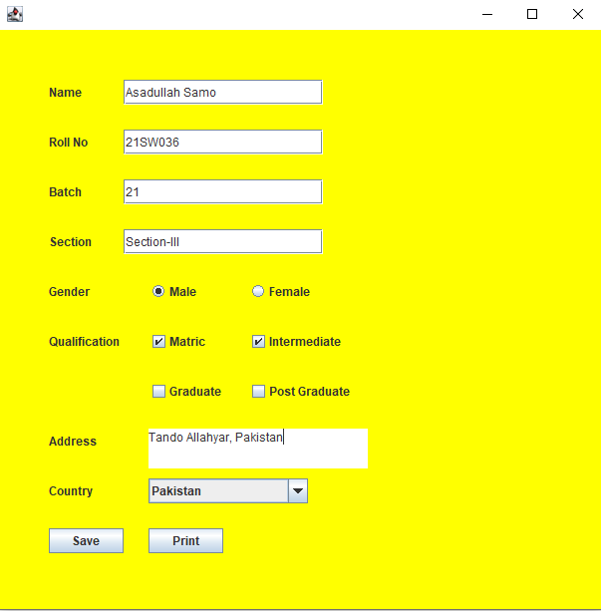

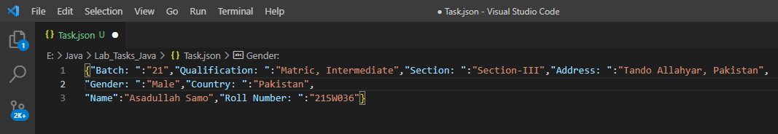

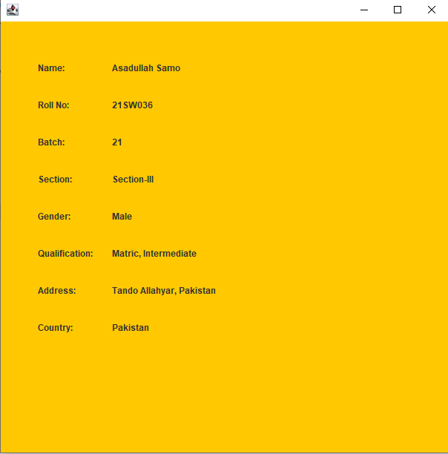

**Link to github:**

<https://github.com/AsadullahSamo/Repository>